**AAC 2024 - Conference & Exhibition**

International Convention Centre, Birmingham

26-27th February 2024

**Date : Stand No :**

**Company Name : Contact Name :**

**Company Address :**

**Post Code :**

**Contact Tel No : Email :**

**GP1 Infill Graphics £170 GP2 Seamless Graphics £210**

**Per 1m wide (apx) Panel Section**

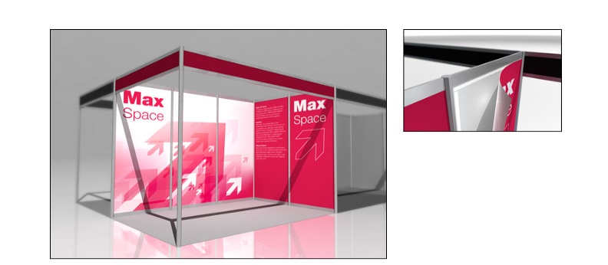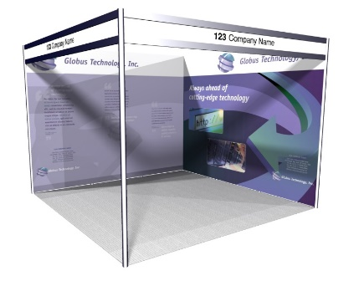

|  |  |  |  |  |
| --- | --- | --- | --- | --- |
|  | **Full Height Foamex Panel System Graphic Options** | **Unit Price** | **Qty** | **Total** |
| **GP/A** | **Full Colour Graphic Infill Panel @ 2340mm H x 950mm W** | **£170.00** |  |  |
| **GP/B** | **Full Colour S/S Graphic Infill Panel @ 2340 mm H x 660mm W** | **£120.00** |  |  |
| **GP/SS** | **Full Colour Graphic Seamless Panel @ 2.5m x 1m W (approx)** | **£210.00** |  |  |
| **GP/C** | **Full Colour S/S Graphic Infill Panel @ 880mm H x 950mm W** | **£80.00** |  |  |
| **DX1** | **Graphic Panel Disposal Charge (Per Panel)** | **£10.00** |  |  |
|  |  | **Sub Total** |  |  |
|  |  | **VAT** | **20%** |  |
|  |  | **TOTAL** |  |  |

**All artwork to be prepared and supplied by Exhibitor in High Resolution PDF Format**

**All Graphic Orders to be received no later than the 5th February 2024**

**Full payment required with receipt of order.**

**BACS Electronic Bank payment details will be provided on Invoice.**

**To process your order, please complete above order form, scan and Email to info@lionexhibitions.com.**

**If you have any queries please contact Andy Guest :- +44 (0)7826 906514**