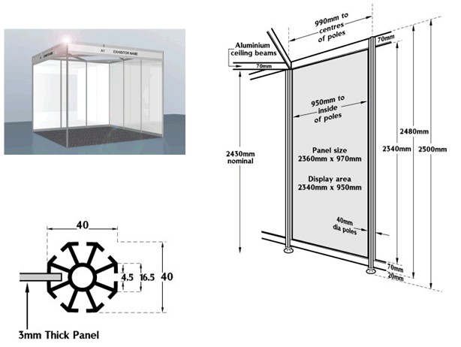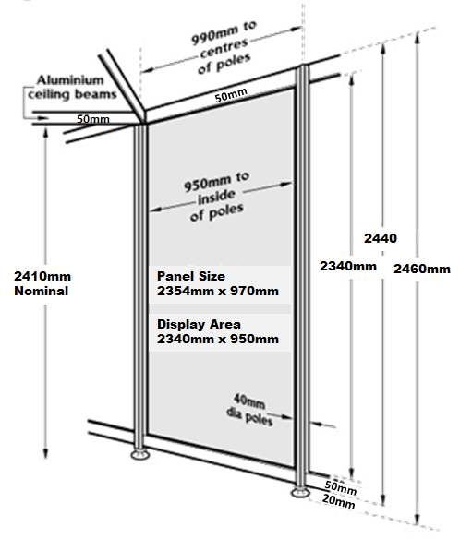

**Foamex Panel / Metalwork Fixings Do’s & Do Not’s**

***Permitted Strictly Not Permitted***

**Blu Tack Products Hammer / Nail Fixings**

**Double Sided Mesh Tape - Screw / Staple Fixings**

***Available from Lion Exhibitions* Liquid Bonding Agents (Glue)**

**Packaging Tape / Sellotape**

**Double Sided Adhesive Tape**

**Double Sided Adhesive Foam Tape**

**Velcro Hook & Loop Tape**